**SCM Sample Assignment Problem Statement ( Task 1.1 )**

**Title:** Implementing Git Basics

**Problem Statement:** You are part of a small development team working on a project. To ensure efficient version control, you are tasked with performing and demonstrating the following operations using Git and GitHub:

**1. Repository Setup and Initial Commit:**

Create a new GitHub repository for the project.

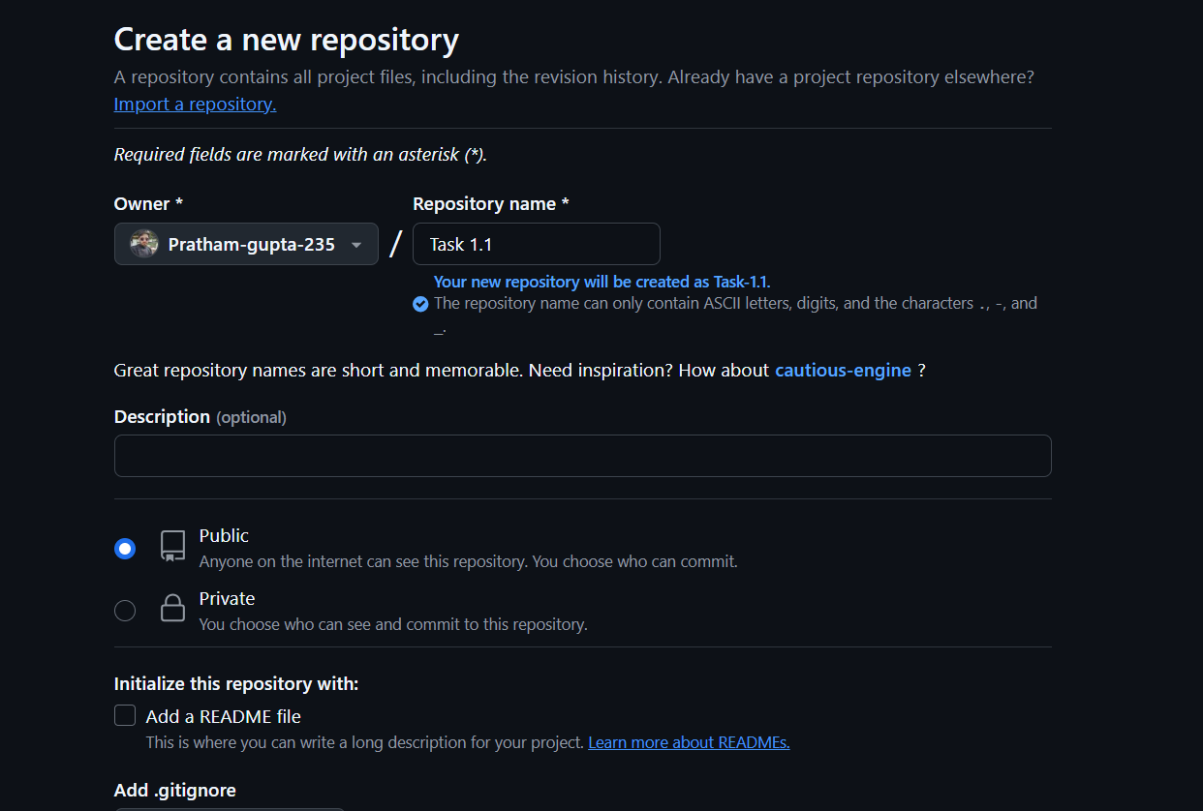

**Clone the repository to your local system**

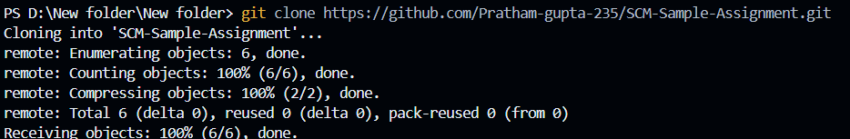

I**nitialize it with a main branch**

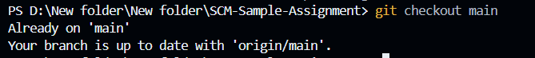

**Create an initial commit that includes a file named project_overview.txt with a brief description of the project.**



2. Branch Creation and Updates:

Create a new branch named feature-update from the main branch.

In this branch, add a file named feature_details.txt containing details of a new feature you plan to implement.

Commit your changes to the feature-update branch.

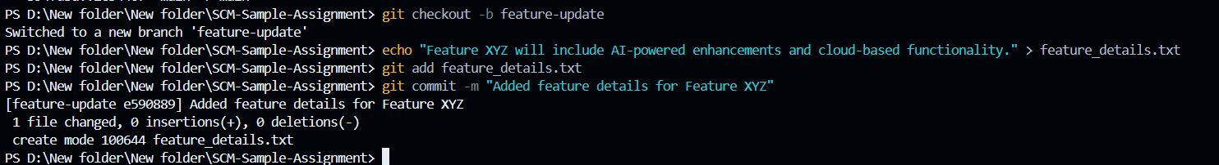

3. Merge and Conflict Resolution:

While working on the feature-update branch, simulate a merge conflict:

o Modify the feature_details.txt file in the main branch.

o Attempt to merge the feature-update branch into the main branch and resolve the conflict using Git Bash.

o Commit the resolved changes to complete the merge.

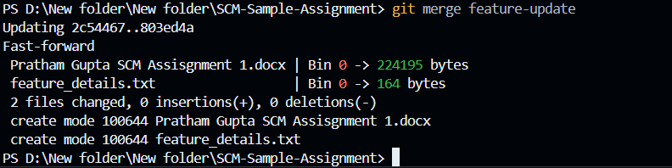

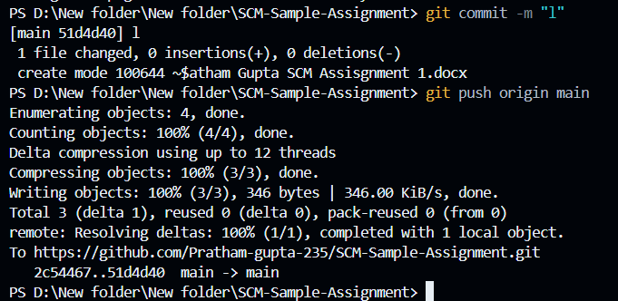

4. **Repository Audit:** Use Git commands such as git status and git log to review the repository status and commit history. Document the key actions performed, including branch creation, commits, merges, and conflict resolutions.

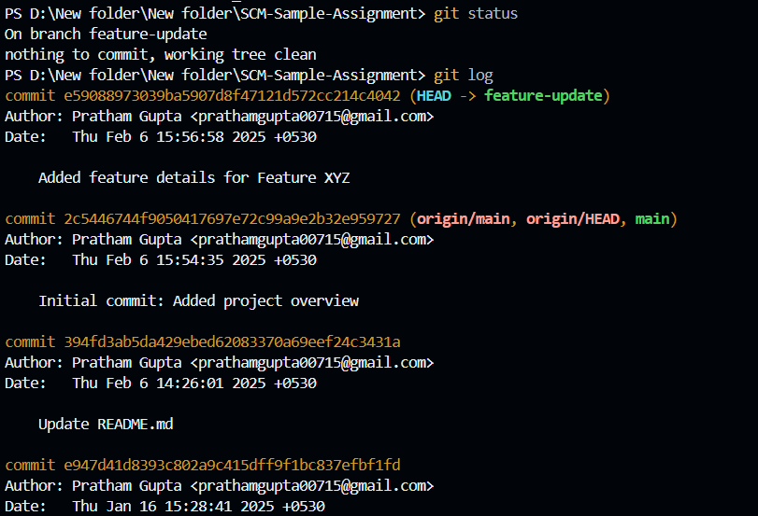

**Evaluation Criteria:**

Proper implementation of Git commands.

Successful resolution of merge conflicts